**Post-Work: Assignment - Plan for Meaningful Life**

C3 EMCS2400: Effective Leadership

Brian Russel Davis, [brian_davis@brown.edu](mailto:brian_davis@brown.edu)

**Title: “Stop Searching For What You Already Are”**

For most people in our time, meaning is lost when they trade their time for money at a job they don’t like and trade wisdom for a daily social media addiction. As humans, our perception of time makes us unique and presents a serious challenge to our idea of meaning. From the perspective of the divine time is endless and from the perspective of an animal, time does not exist. For us, and only for us, time is a constant reminder that our hopes and dreams are limited, as we wait for our final moments. For many, this propels us into a frantic sorrowful search for meaning -- to find it, obtain it or capture it. I joined this race for a while until I realize a simple truth. Meaning must be accepted, not achieved, much in the same way Love can be accepted and not achieved. When I feel the fullness of Agape Love in my life, my actions and reactions to people, situations and even catastrophic events add to a meaningful life. When I accept Love, I don’t search for it or try to make it. Love and Meaning cannot be made or obtained. It is not something we put on a bucket list. Meaning is our deep acceptance that we are wanted, just the way we are. Planning a meaningful life, and becoming a meaningful leader is “overflow” of this acceptance, one that permeates our thinking, our actions and most importantly our words.

As a young child, the person who showed this to me was Fred Rogers, better known as Mister Rogers. He looked into the camera day after day and spoke a very simple truth about Love to millions of children. This truth can be summarized as such: We don’t have to work to achieve Love, we are *immutably* and irrevocably Loved, just the way we are. He did not *give* me Love, but he showed me this truth early on, and it helped me build up ways to protect this truth from everything and everyone that would try to take it away. It is frightening that this lesson is not taught to children that often. Instead, we tend to teach hero worship with a world framed as a battle between good and evil. In our modern times “leadership” has become the clever practice of pedagogical wordplay.

What does this mean for leadership? A leader who embraces this is less likely to make selfish short-sighted decisions. They are not seeking to save themselves from this or that. They will plunge headlong into the most harrowing of circumstances without expectations for self. These are the men who stepped off the boats at Omaha beach. These are the people that crossed the Edmund Pettus Bridge. This explains the actions of people like Harriet Tubman and [18-year-old Brandt Jean hugging his brother killer](https://www.usatoday.com/story/opinion/2019/10/05/amber-guyger-brandt-jean-hug-forgiveness-column/3867057002/). These are people that lead when others are trying to find their footing, are searching for meaning or calculating the cost. All of the people I have reference became meaningful in the moments when it mattered the most. This echoed in the words of William Ernest Henley who wrote Invictus after losing his leg to a horrid illness at a very young age.

*Out of the night that covers me,*

*Black as the pit from pole to pole,*

*I thank whatever gods may be*

*For my unconquerable soul.*

*In the fell clutch of circumstance*

*I have not winced nor cried aloud.*

*Under the bludgeonings of chance*

*My head is bloody, but unbowed.*

*Beyond this place of wrath and tears*

*Looms but the Horror of the shade,*

*And yet the menace of the years*

*Finds and shall find me unafraid.*

*It matters not how strait the gate,*

*How charged with punishments the scroll,*

*I am the master of my fate,*

*I am the captain of my soul.*



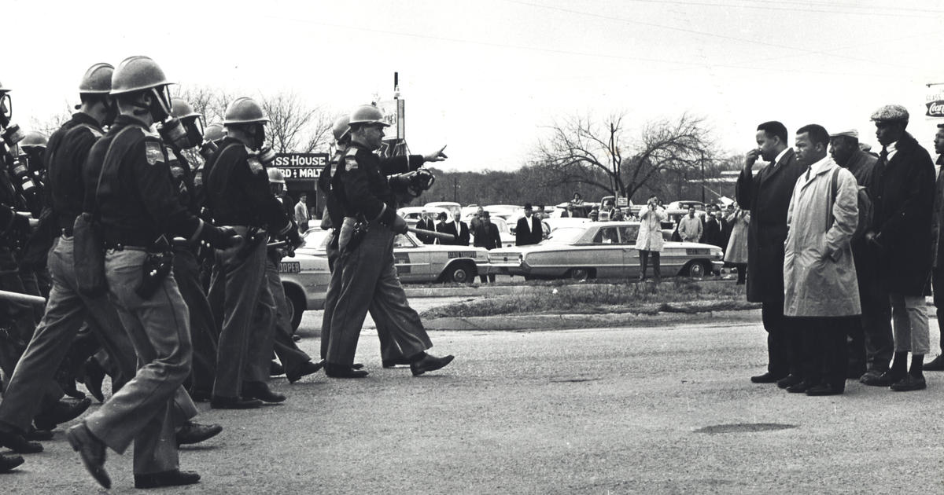

In conclusion, I would like to challenge the question asked in this assignment. Can you really “plan” a life full of meaning? Can you plan to be a meaningful leader? Or does it make more sense to accept that you are meaningful? Should we spend our time chasing meaning? Or should we spend our time removing the negative programming that seeks to make us fearful that we aren’t meaningful enough? In my opinion, planning to be something you already are is an anti-pattern and a self-fulfilling failure. Allowing meaning to “fill up” one's soul is the path to being the type of leader and person that will make decisions and take action in the moments that matter.